Lab 5.

Docker Containers

Docker container to setup the Kubernetes.

Installing Isto:

Installing the isto after downloading from the Github.

Isto is installed and running

Deploying The Book Info:

Apply and Getting Services:

Book info sample working now.

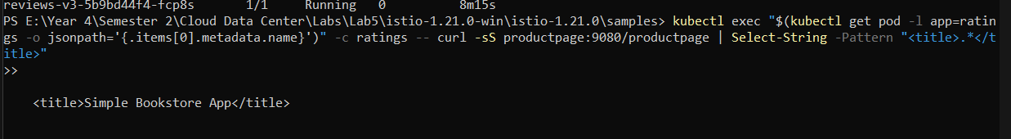

**Open the application to outside traffic:**



Ingress the IP and Gateways.

Verifying the External Access:



Viewing the Dashboard:

“istioctl dashboard kiali” with this command it opened a webpage.

“1..100 | ForEach-Object {

Invoke-WebRequest -Uri "http://$GATEWAY_URL/productpage" | Out-Null

}”

With this command it showed the graph.